**Name:**

***Full working out must be shown to get full marks.***

***Attempt all questions***

**Total Time: Part A- 25 mins (24 Marks)**

**Part B- 30 mins (29 Marks)**

**Calculator Free Section**

TIME ALLOWED: 25 min Total marks: 24

**Question 1: [1mark]**

A bag of 30 lollies has 18 red ones, and the rest are black. If the first two lollies taken at random are black, what is the probability the next one will be red?

**Question 2: [5 marks: 2, 1, 1, 1]**

In a certain group of 60 year 11 students, there are 35 students who study History(H), there are 45 students who study Biology (B) and there are 30 students who study both History and Biology.

1. Show this information in the Venn Diagram:

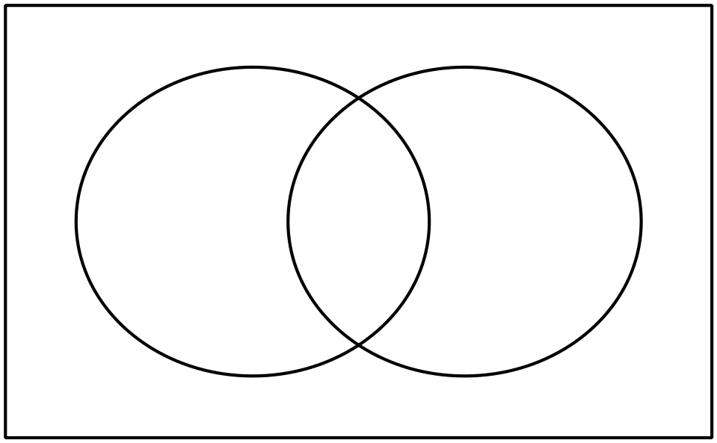

H

B

Find the probability that a selected student:

1. only studies History

c) does not study History given they study Biology

d) studies either Biology or History

**Question 3: [3 marks: 1, 2]**

Shade the following Venn Diagrams according to the area indicated.

1. $A'∪B$ b) $A^{'} ∩ (B∪C)$

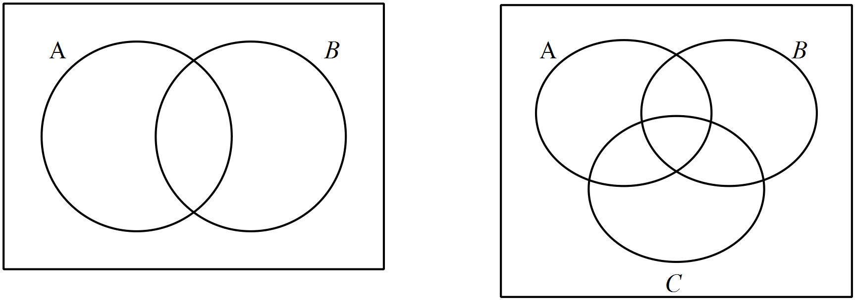

**Question 4: [5 marks: 2, 2, 1]**

Given that $P\left(\overline{A∪B}\right)=0.2 , P\left(B\right)=0.4$ and $P\left(A∩B\right)=0.2$;

1. Find $P\left(B | A\right).$
2. Determine with reasons if the events A and B are independent.
3. Determine with reasons if the events A and B are mutually exclusive.

**Question 5: [8 marks: 2, 3, 3]**

1. How many ways can I pick a team of 3 people from a group of 10.
2. How many 3-letter words with or without meaning, can be formed out of the letters of the word, 'LOGARITHMS', if repetition of letters is not allowed?
3. A box contains 4 red, 3 white and 2 blue balls. Three balls are drawn at random. Find out the number of ways of selecting the balls of different colours?

**Question 6: [2 marks: 2]**

Use Pascal’s Triangle to fully expand the expression .

End of Part A